ALPHAWAVE INTERVIEW QUESTIONS

1. Can nMOS and pMOS be ON at the same time?
- In CMOS logic, both are not ON at the same time in steady state (this avoids short-circuit current).
- During switching (transition from 0 to 1 or 1 to 0), there is a small period where both conduct → called short-circuit current.
(can it cause powerloss - Yes, it causes power loss.
How (easy interview answer):
When NMOS and PMOS are ON at the same time, a direct path from VDD to GND is created. This allows current to flow continuously, even without charging or discharging a load, causing short-circuit power loss.)
If both NMOS and PMOS are ON, it creates a direct path from supply to ground, causing high current and power loss.

2. How does STA work to AND gate output 1?
In Static Timing Analysis (STA), an AND gate output is considered 1 only when all inputs are 1. STA checks the latest arriving input (critical path) because the output can become 1 only after the slowest input reaches logic 1.
Key interview line:
For AND gate output = 1, STA uses the maximum input arrival time to determine the output timing.
Why:
- AND gate waits for all inputs = 1
- Slowest input decides when output becomes 1

Below is for all Gates :
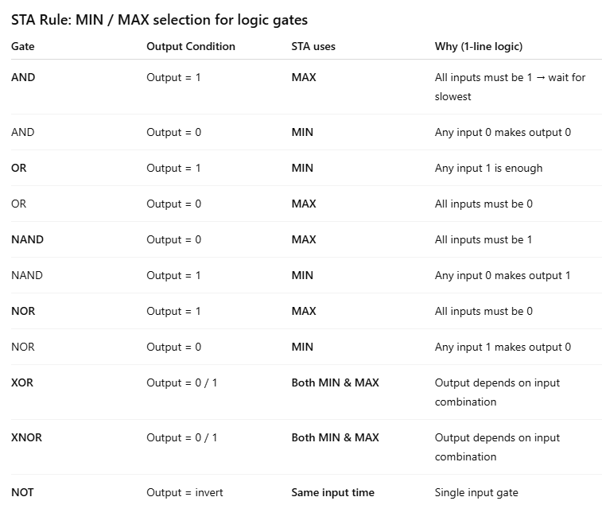
3. Define fsm, mealy and moore
Finite state machine is a mathematical computation model consisting of finite number of states, transition between those states and actions used to control the execution flow in a system .
FSM (Finite State Machine) is a digital system that has a finite number of states and changes from one state to another based on inputs and clock signals.

A Mealy FSM is a type of FSM where the output depends on both the present state and the current input.
→ Output can change immediately with input change.
Interview keyword: Fast response

Moore Machine – Definition
A Moore FSM is a type of FSM where the output depends only on the present state.
→ Output changes only on clock edge.
Interview keyword: Stable output

4. Sequence detection 1011 using both Mealy and Moore- NB

5. Asynchronous D Flip-Flop with HIGH reset
module dff_async_high_reset (
input wire clk,
input wire rst, // active HIGH reset
input wire d,
output reg q
);
always @(posedge clk or posedge rst) begin
if (rst)
q <= 1'b0;
else
q <= d;
end

endmodule

6. Synchronous D Flip-Flop with LOW reset
always @(posedge clk) begin
if (!rst_n)
q <= 1'b0;
else
q <= d;
end

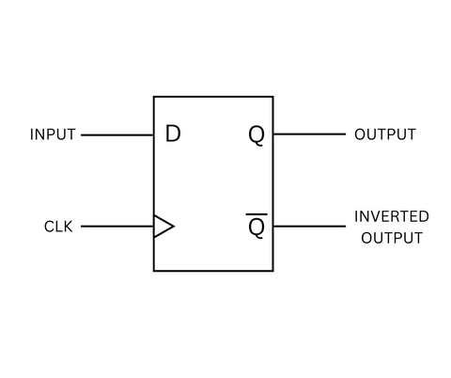
7. Draw D flipflop:

A D flip-flop stores the value of D at the active clock edge and outputs it at Q.
Between clock edges, the output remains constant.
Signal meaning (very short):
- D → Data input
- CLK → Clock (edge-triggered)
- Q → Output
- Q̅ → Complement output

8. Define setup and hold time
- Setup time : It is the minimum time for which the data input must be stable before the a clock edge
- Hold time: It is the minimum time for which the data input must be stable after the a clock edge

9. How to overcome on setup and hold violation
To fix Setup Time Violation:
- Reduce data path delay (optimize logic, use faster cells)
- Increase clock period (lower clock frequency)
Goal: Make data arrive earlier before clock edge

To fix Hold Time Violation:
- Add delay buffers in data path
- Reduce clock skew
Goal: Make data arrive later after clock edge
One-line memory trick (interview gold):
- Setup → speed up data
- Hold → slow down data

Clock skew is the difference in arrival time of the same clock signal at different flip-flops.
Types:
- Positive skew → clock reaches destination later
- Negative skew → clock reaches destination earlier

Delay is the time taken for a signal to travel from input to output.
Types:
- Propagation delay → time for output to respond after input change
- Contamination delay → minimum time before output starts changing

10. Different types of Stability
- Stable State
A condition where the output settles to a valid logic 0 or 1 and remains unchanged.
- Unstable State
A condition where the output keeps changing and does not settle to a valid logic level.
- Bistable state
A bistable state is a condition in a system where it has two stable states and can remain stable in either state until an external input changes it.
- Metastable State
A temporary condition where the output is neither 0 nor 1 and stays in an undefined state for some time.

Metastability – Definition
Metastability is a condition in flip-flops where the output enters an undefined voltage level due to setup or hold time violation, and takes an unpredictable time to settle to 0 or 1.

11. Define DFT and DV
DFT is a design methodology in which extra test logic is added to the circuit so that manufacturing defects can be easily detected after fabrication.

Design Verification is the process of checking whether a hardware design correctly meets its predefined specifications and functions.

12. MOSFET Operational Modes
MOSFET operational modes describe the different regions in which a MOSFET operates based on gate-to-source voltage (VGS) and drain-to-source voltage (VDS).

1️⃣ Cut-off Region
Definition:
MOSFET is OFF when VGS < Vth.
→ No drain current flows.

2️⃣ Triode (Linear) Region
Definition:
MOSFET is ON and behaves like a resistor when
VGS > Vth and VDS < (VGS − Vth).

3️⃣ Saturation Region
Definition:
MOSFET is ON and behaves like a current source when
VGS > Vth and VDS ≥ (VGS − Vth).

One-line interview summary:
A MOSFET operates in cut-off (OFF), linear (resistive), or saturation (current source) depending on VGS and VDS.

13 .MOSFET vs BJT in size — which is bigger?
- MOSFET can be made much smaller than BJTs in IC fabrication.
- BJT requires more doping and larger base-collector junction to efficiently collect carriers and handle higher voltages.
- That’s why modern processors use MOSFETs for billions of transistors.

14. 2:1 MUX Verilog Code
module mux2_assign (
input a, b,
input s,
output y
);
assign y = s ? b : a;
endmodule ( dataflow style )

always @(*) begin
if (s)
y = b;
else
y = a;
end
endmodule (Behavioral style)

1️⃣ Behavioral Modeling
Definition:
Describes what the circuit does using always blocks (if, case, loops).
Keywords: always, if, case
Example: FSMs, control logic

2️⃣ Dataflow Modeling
Definition:
Describes how data flows using continuous assignments.
Keywords: assign, operators
Example: MUX, combinational logic

3️⃣ Structural Modeling ✅ (the missing one)
Definition:
Describes the circuit using gate-level connections, similar to a schematic.
Keywords: and, or, not, module instantiation
Example: Gate-level design

15 . 4:1 Mux
module mux4_case (
input [3:0] d,
input [1:0] s,
output reg y
);
always @(*) begin
case (s)
2'b00: y = d[0];
2'b01: y = d[1];
2'b10: y = d[2];
2'b11: y = d[3];
endcase
end
endmodule (Behavariol)

assign y = (s == 2'b00) ? d[0] :
(s == 2'b01) ? d[1] :
(s == 2'b10) ? d[2] :
d[3]; ( dataflow )
• Behavioral → always, if, case
• Dataflow → assign, expressions
• Structural → not, and, or ✔️

16. Blocking Assignment and Non blocking assignments
A blocking assignment (=) executes statements sequentially, meaning the next statement waits until the current assignment is completed.
Where used: Combinational logic (always @(*))

A non-blocking assignment (<=) schedules updates to occur simultaneously at the end of the time step, so statements do not block each other.
Where used: Sequential logic (always @(posedge clk))

17. latch Vs flipflop
A latch is a level-sensitive storage element that allows data to pass to the output as long as the enable signal is active.

A flip-flop is an edge-triggered storage element that captures data only at the specific clock edge(falling or rising )

Level Sensitive
Circuit responds as long as input/clock is at a particular level (0 or 1)
- Output changes continuously while enabled
Line: Works during the level (HIGH/LOW)

🔹 Edge Sensitive
👉 Circuit responds only at the instant of clock transition
Key:
- Triggered at:
  - Rising edge (0 → 1)
  - Falling edge (1 → 0)
- Example: Flip-flop
- Output changes only at that moment
👉 Line: Works only at the edge (transition)

18. Setup and hold using timing diagram – in vlsi interview questions NB

19. Combiantional and sequential ckt
A combinational circuit is a digital circuit whose output depends only on the present inputs and has no memory.
Examples:
Adder, MUX, Decoder
A sequential circuit is a digital circuit whose output depends on present inputs and past outputs, because it contains memory elements (latches/flip-flops).
Examples:
Flip-flops, Counters, FSMs

